

Referral Agency Guide to

E-referral

## What is e-referral?

E-referral is a way to refer a client to Neath Foodbank on Trussell Trust’s online system, without the need for a red voucher (our old method of referring clients). This works by entering the client’s details are entered onto the database and a personalised voucher is printed for them to take to the foodbank.

## Why use e-referral?

* + Your staff will not need to carry red vouchers, nor need to re-order them.
  + The client details you enter into the system will be immediately accessible to the foodbank when the client visits. This will improve our ability to help your clients, and will reduce the errors that arise when transcribing entries from hand-written vouchers.
  + Data confidentiality
  + Trussell Trust uses anonymized referral data to monitor trends and campaign work.

# Signing up for e-referral

Contact us to register to use the e-referral system. You will receive an email invitation with a link labelled “Accept invitation”. When you click this link, you will be taken to the e-referral website to enter your details and set a password.

## Accessing the data system

The foodbank client data system is accessed on-line via <https://data.foodbank.org.uk> . You’ll need to log in using your email address and password.

Once you are in the data system, you will see a menu bar with five main options:



To prepare for use of the system, you will first need to visit **Settings** and carry out two tasks:

1. Check your **Agency details** are correct.

If your details change in the future, please edit them here. The foodbank will then always have your latest contact details.

1. Click **Users** to give your staff access to e-referral:

## Adding Users

You will need to add into the system the details of staff that you want to have access to e- referral. To do so, click on the **Invite new user** button.

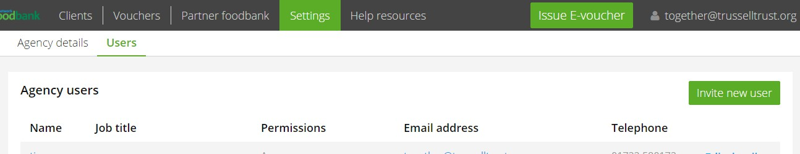

You will be asked for their name, job title, email address, phone number (optional), whether they are a “user” or “manager” and whether they have signed a data protection statement. Managers have the ability to add, edit and remove users, and amend the “agency details”, as well as all the other functions available to all Users.

Once you have entered a user’s details, click the **Send invitation** button. The user will then receive an email similar to the one that invited you to e-referral.

To remove access for one of your staff, go to **Settings/Users**, find their name, click **Edit details**, and click **Delete** and the bottom of the screen.

**Reporting problems**

Please contact us if you’re unsure about when and how to make e- referrals, or if you have any technical problems.

## Data security

Like all foodbanks in the Trussell Trust network, Neath Foodbank takes data security seriously. Client data in the e-referral system is fully encrypted, and adheres to GDPR policies.

# Making referrals

To make an e-referral, log into the data system and click on the **Issue e-voucher**

button. This starts a six-step process:

1. *Step 1: Search for client*

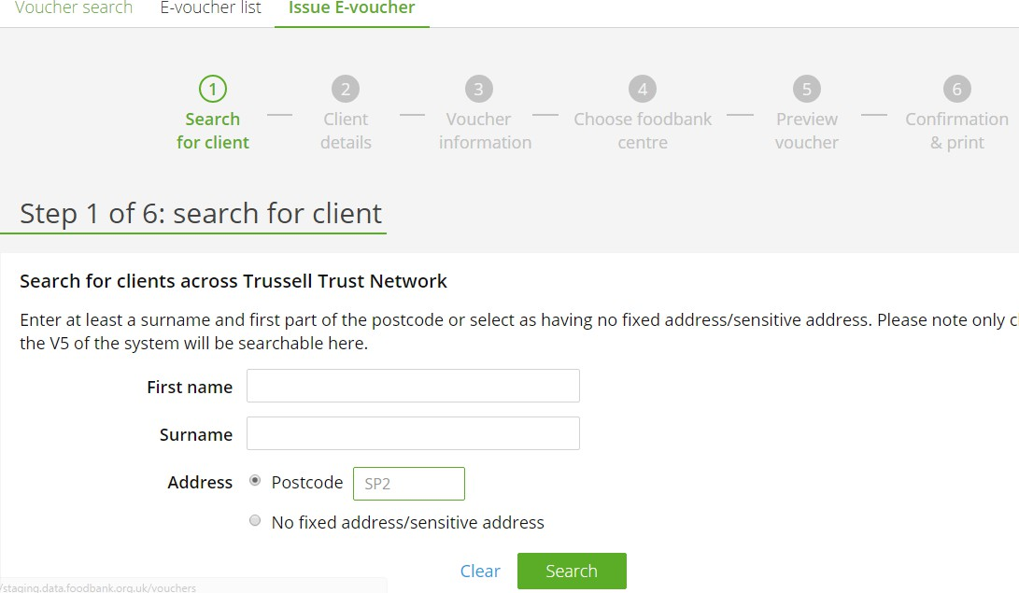

Enter the client’s details and click **Search** to see if they are already in the system.

You will need to enter at least their surname and at least the first part of their postcode. Any matches will then be displayed.

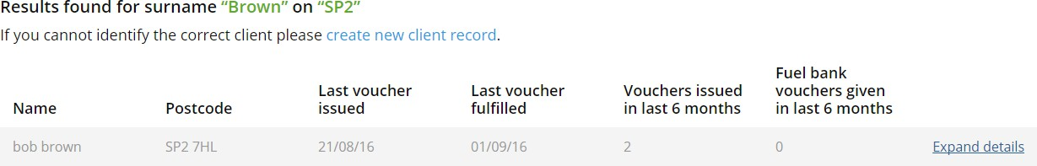

If the correct client is not listed, click on **create new client record**. You will be taken to

*Step 2: Client details*.

If the correct client is listed, click on **Expand details**. You will see the history of foodbank vouchers for this client, and for anyone else at the same postcode (unless the location has been flagged as a “sensitive address”, such as a women’s refuge).

If the voucher history raises no concerns, click on **Issue voucher.** You will be taken to *Step 2*, with the known “client details” will already be displayed. You will be able to amend these details if you need to, or go straight to *Step 3: Voucher information*.

*Step 2: Client details*

At this stage, record the main information about the client:

* First name
* Surname
* Whether the client has no fixed abode, or a sensitive address
* Details of the address
* Postcode
* Year of birth
* Ethnicity
* Number of adults and children in the household

These details will be retained for any future referrals. If they change in the future, they can always be amended, either as a temporary change (for example, if children come to stay for a while) or a lasting change.

*Step 3: Voucher information*

This is the main stage in the referral process, where you record details about this particular referral. It consists of two parts.

The first part is “Referral agency information”. This displays your agency name, contact number and the name of the staff member making the referral. The staff name and contact number can be amended, if necessary. This information will be visible to the foodbank, and will help them if they have a query or need to speak to the referrer.

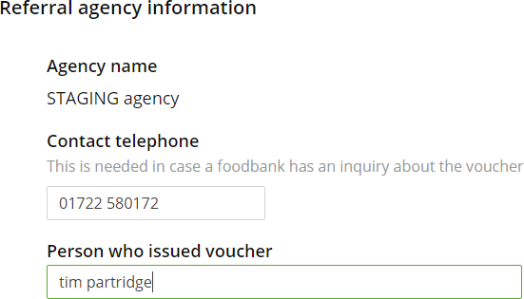

The second part deals with “Client circumstances”. This information will help the foodbank understand the client’s situation, and so be better able to help them. It will also provide valuable insights into patterns and trends lying behind demand for foodbank assistance.

* 1. *Can the client provide ID when collecting food at the foodbank?*

It is preferred if clients can bring ID when visiting the foodbank with a printed e- referral voucher. If a client has no suitable ID, you can still refer them – please contact us about this beforehand.

* 1. *Number of adults and children currently in the household*

These should already be correct, but can be edited at this stage if necessary.

* 1. *Is anyone living in the household employed?*

Please record this information if known, or if the client is willing to share it.

It does not affect in any way the help the client will receive from the foodbank.

* 1. *Main cause of crisis*

Please record what you judge to be the main cause of the client’s crisis.

This is optional, but helps us understand the client’s situation and need for support, as well as informing understanding about the causes of food poverty.

If none of the eleven main causes of crisis are appropriate, you can select “other” and record relevant information in a text box.

* 1. *Secondary causes of crisis*

Many clients have multiple contributory problems, in addition to the main crisis. Please tick the ones that you believe apply to your client.

* 1. *Additional notes for foodbank*

Use this to record anything you would wish the foodbank to know. This might include things like dietary constraints, language problems, or social difficulty.

However, these notes will only be visible when the foodbank accesses the voucher information in the data system.

*Step 4: Choose foodbank centre*

At *Step 4* you will be shown location details, maps and opening times of the ten foodbank centres closest to the client’s postcode in a straight line.

Four of these will be printed on the client’s voucher. The four closest will already be ticked, but you can change that selection if other foodbank centres are preferable.

Click **Continue** to reach *Step 5.*

*Step 5: Preview voucher*

Step 5 shows the final voucher. If it is to be printed, it will include maps and opening times of the selected foodbank centres.

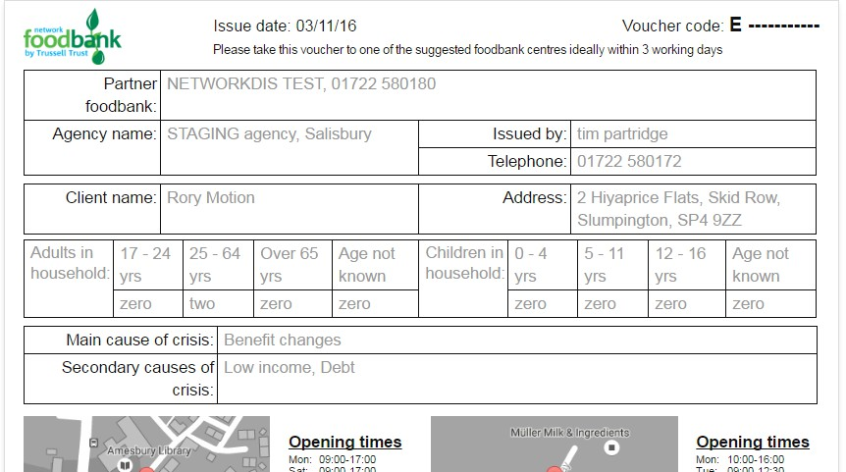

Click **Save & generate voucher code** to reach the final step.

1. *Step 6: Confirmation & print*

The final step displays the voucher number for this client referral.

* 1. If you have selected to print the voucher you will see a **Print voucher** button.

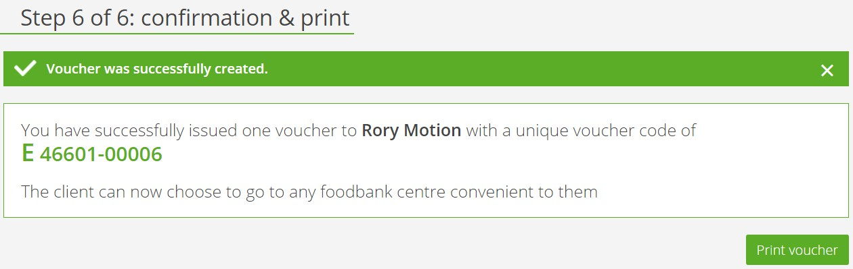

This button generates a PDF of the voucher which can be printed. There is no need to save a copy of the PDF, as the voucher information can always be revisited via the data system.

Please do not send the client a copy of this PDF for them to print. That could be too easily abused.

# Monitoring client use

The data system offers you several ways to monitor activity.

## Voucher search

You can use “voucher search” to look up details of a particular referral.

You could just enter the voucher code and click **Search**. However, there are more useful options available if you click **Show more search options**.

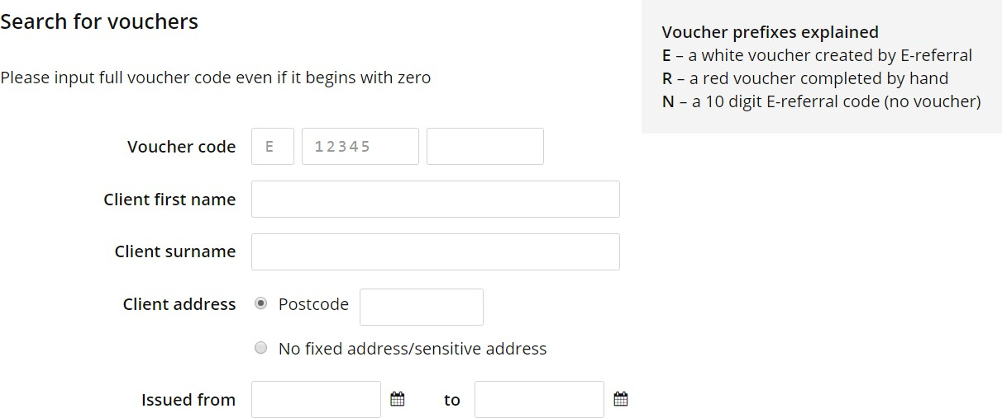

For example, you could search for all referrals for a named client, or referrals related to a particular post code; or you could see all referrals made (vouchers “issued”) in a given period.

The search results will show, for each matching record, the voucher code, client name, issuer name, date of issue and status (“fulfilled” or “unfulfilled”).

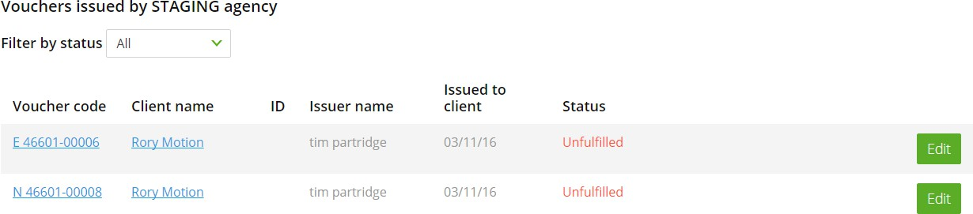

Click the **Edit** button if you want to check or amend the “Voucher information”, such as main and secondary crises.

Alternatively, click on the client’s name if you want to check or amend the “Client details”, such as address.

## E-voucher list

The “E-voucher list” screen also gives you access to the “Voucher search” facility. More importantly, it lists the e-referral vouchers that your agency staff have issued.

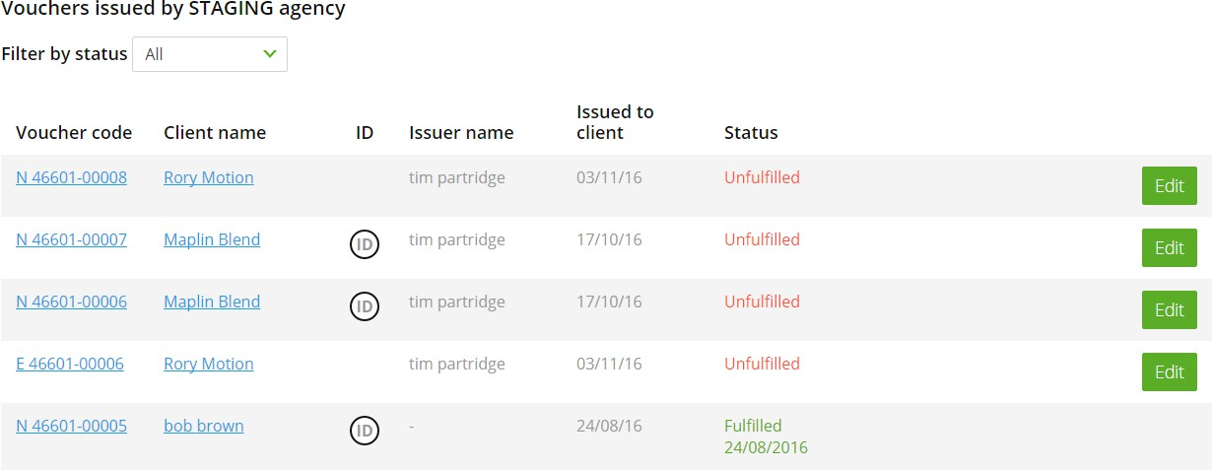

This will help you to monitor activity, showing when vouchers are issued and by which staff members. It will also show when vouchers are being used (“fulfilled”).

If it helps, you can filter this list just to see “fulfilled” or “unfulfilled” vouchers.